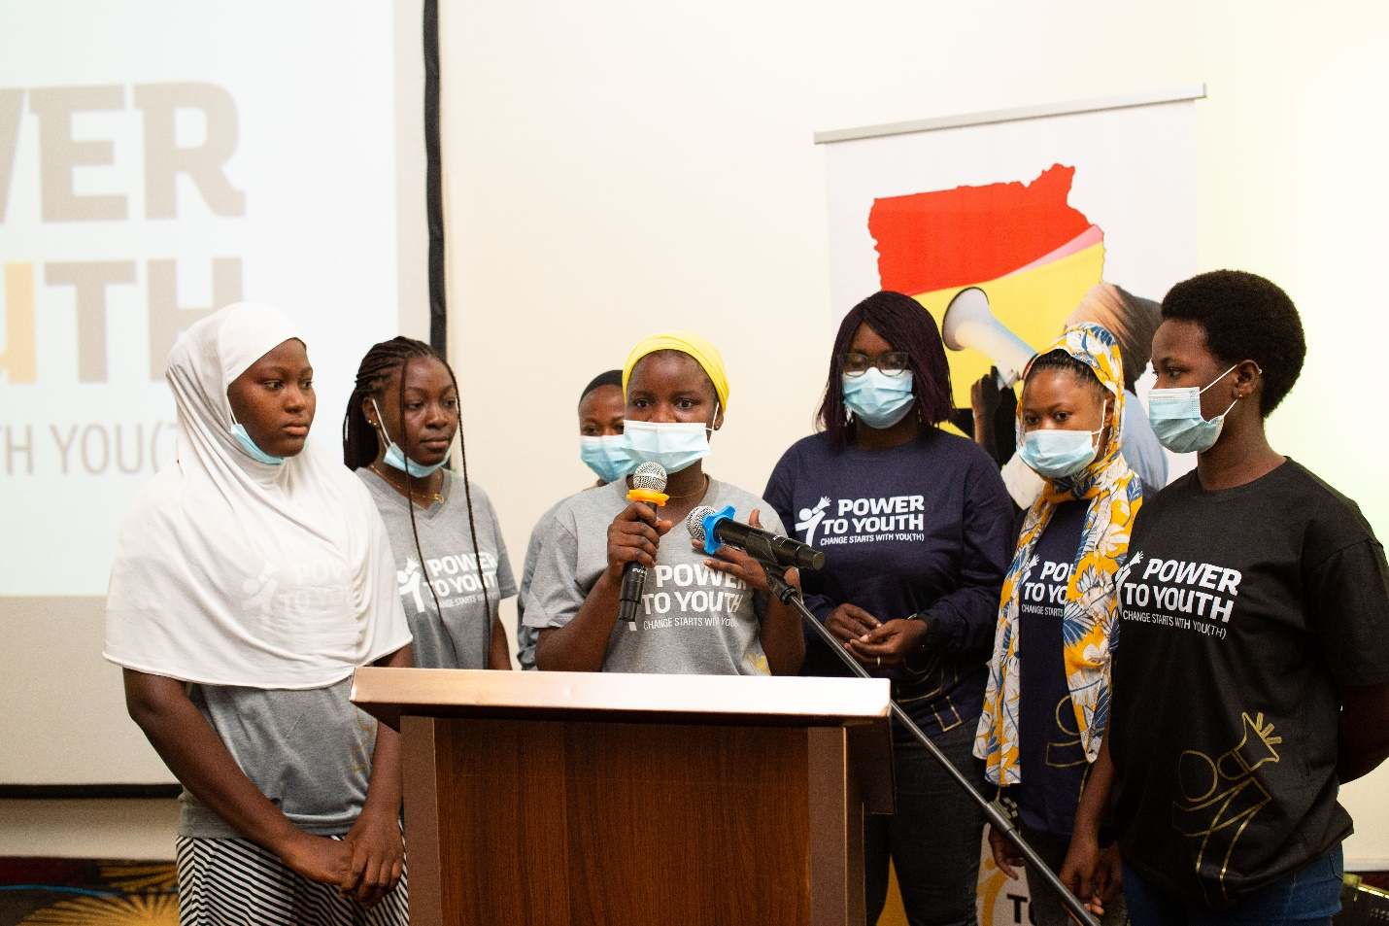

YOUTH INITIATIVE SMALL GRANTS (YISG) REPORT

|  |  |
| --- | --- |
| **PROJECT DETAILS** | |
| **Name of Organization/Youth Network** | Foundation For Community Empowerment Programme (FOCEP) |
| **Project Title** | To End Teenage Pregnancy and Abuse of Emergency Contraceptives |
| **Project Implementing area(s)** | Builsa South District |
| **Focus of Project** |  |
| **Report type** *(colour-fill appropriate report type compiled)* | Progress Report   * Xx * Final Report |
| **Name of person who compiled the Report** | Philomena Akayeng |
| **Name of Project Lead** | Philomena Akayeng |
| **Signature of Project Lead** | C:\Users\Maxwell Akandem\Desktop\All On Desktop\FOCEP AGREEMENT DOCS\philo signature0001.jpg |
| **Date of Submission of Report** | 30th November, 2022 |

Please submit all completed forms via email to [abako@norsaac.org](mailto:abako@norsaac.org) and copy [tillyboma@norsaac.org](mailto:tillyboma@norsaac.org), [kawusada@norsaac.org](mailto:kawusada@norsaac.org), [bashirat@norsaac.org](mailto:bashirat@norsaac.org), [hafsah@norsaac.org](mailto:hafsah@norsaac.org), [annika@norsaac.org](mailto:annika@norsaac.org) with subject line: “YISG Report Submission”

Thank you so much for your willingness to share the story of your impact! This report will help us understand and advocate for your needs. Please answer succinctly but give enough detail for us to describe your work to a potential funder. (Roughly 150-250 words per question).

1. **Beneficiaries Served**

*Please describe how many adolescent girls and young women you served, as well as any information you have about their different categories; age, ability, minority tribe, etc. What were your outreach methods with the beneficiaries and how were the different responses of the beneficiaries?*

To begin with, during the reporting period under consideration, the project implementation team undertook a monitoring and evaluation exercise to assess the progress of activities among the various school clubs establised and trained. Per the assessment, Fumbisi Junior High Model School and Kanjarga Junior High School (JHS) implementation of activities are progressing on very well. It is refreshing to note that these school clubs have been holding weekly activities within their respective schools to sensitize their peers on the dangers of teenage pregnancies and emergency contraceptives on the life’s of teenagers. It is heart-warming to note that during the monitoring visits, the Fumbisi Junior High Model School reported there was a rape case and due to the empowerment training they received by FOCEP under the P2Y program they reported the perpetrator to the police for arrest and subseqquently the perpetrator was taking to Court and he has since been incarcerated for the offence committed. This is so impartful and good news worthy of reporting and this has sent a very strong signal to all potential perpetrators as a deterrent measure to all.

Another important activity implemented by the project team during the period under review, is the facilitative role the team played in the establishment of the Kanjarga Senior High School club. The school club members were sensitized on their collective functions and role of each executive leader they elected. The first session, club members received training on the following topics to enhance their effective operatinalization: group dynamics, conflict management, record keeping, minutes recording, procedures during club meetings and development of simplified constitution to regulate their operations. The second session of the club meeting focused on youth empowerment issues on teenage pregnancy prevention, negative implications of emergency contraceptives, retention of grils in schools and reporting/referral mechanism of perpetrators of teenage pregnancies to the various social justiice institutions for appropriate actions.

Equally important activity that project implementation team executed successfully during the period under consideration is the formation and establishment of the Fumbisi Senior High/Agrich School club with total membership 0f 121 exceeding the planned target of 50 per the work plan. Per the strategy of the project team to build the capacities of the members of the club during the first session took members through the following principle of clubs such as group dynamics, record keeping, minutes records, elections of executive members, development of club constitutions, conflict management and resolution among others. It is also important to note that during the second session, the project implementation team trained the entire membership of the club on teenage pregnancy prevetion measures, negative implications of emergency contraceptives, high retention rate for young girls, referral path-ways and reporting systems of cases to the appropriate social justice institutions. The clubs were trained on how draw up action plans for implantion of their planned activities.

It is pertinent to note that, the project team was able to reach out to thousands of young people and community members through the community Radio program. With respect to the radio discussion a total number of five (5) sessions has been organized with a total number of 5 people including 2 (2) young people participating in the sessions. It is remarkable to note that the Radio session has built the capacities of the panellist especially young people with their advocacy and communication skills. The following selected topics were discussed: Sexual and Gender Based Violence (SGBV) negative effects teenage pregnancy on young girls, negative effects of emergency contraceptives, negative effects of early marriages on young girls, negative effects teenage pregnancy on the young girls education and future develoments. It is worth noting that during the dicussions of the above topics a total number of 167 people phone-in to ask questions for clarifications and some phone-in calls made very positive constributions to enhance communnity participation of the radio program.

1. **Beneficiary involvement**

*Please describe how beneficiaries were involved in the implementation of activities.*

With respect to involvement of project beneficiaries, the project implementation team adopted a broad based and an all-inclusive participatory approach by ensuring that all target beneficiaries were duly consulted and adequately involved in the planning and implementatation stages of the intervention to ensure continuity of the intervention. It is against this backdrop that, before the formation of these clubs the primary beneficiaries were consulted before the establishment of the various school clubs. In addition, these primary beneficiaries such as students of the various school clubs have been trained to draw their own program outline to implement their own planned activities independently with minimum supervision.

1. **Meaningful Youth Participation and Engagement**

*Describe how youth especially Adolescent Girls and Young Women (AGYW) were involved in the planning and implementation process*

With regard to the issue of meaningful youth participation and engagement, the project implementation team ensured that from the level of field mobilization, club formation at the school levels and implementation of project activities, the youth who are the primary beneficiaries were involved in all the levels of project activities to enhance meaningful youth participation. In addition, the youth participated fully in the radio discussion sessions to enhance their participation and this afforded the youth the opportunity to express their views and concerns that militates against the growth and development. As a result of their participation, the youth capacities have been developed and they are well empowered to engage with stakeholders to hold them accountable.

1. **Progress to objectives and targets.**

*Referencing the goals stated on the application, please describe progress to stated objectives and deliverables. Where appropriate, indicate a quantifiable metric that articulates impact, and describe what leads to that result.*

The project implementation team, begun the implementation of project activities with monitoring and evaluation of previous activities carried during the first phase to ascertain progress of work. The monitoring team visits revealed that the both school clubs at the Fumbisi Junior High Model School and Kanjarga Junior High School (JHS) activities were progressing very well and the clubs were having regular meetings and engagements with their peers in their respective schools. It is refreshing to note that during the monitoring visits, the Fumbisi Junior High Model School reported there was a rape case and due to the empowerment training they received by FOCEP under the P2Y program they reported the perpetrator to the police for his arrest and subsequently the perpetrator was taking to Court and he has since been incarcerated for the offence committed. This is so impartful and good news worthy of reporting and this has sent a very strong signal to all potential pertrators as a deterrent measure to all.

Another remarkable progress made during the second phase is consistent weekly Radio program being facilitated by the project implementation team to create awarenes about the menance of teenage pregnancy and its negative implications on the young people in the Builsa South District. A total of five (5) Radio sessions were organized during the period under consideration and the following topics were discussed to create awareness on : Sexual and Gender Based Violence (SGBV) negative effects teenage pregnaciy on young girls, negative effects of emergency contraceptives, negative effects of early marriages on young girls, negative effects of teenage pregnancy on the young girls education and future develoments. The involvement of young people in the radio program has improved upon the advocacy and communication skills thereby increasing their knowledge base for effective cooperation with strategic stakeholders.

The project implementation team made positive strides by facilitating the establishment of the Kanjarga Senior High School club. The school club receive training in the following disciplines: group dynamics, conflict management, record keeping, munites recording, procedures during club meetings and development of simplified constitution to regulate their operations. The second session of the club meeting focused on youth empowerment issues on teenage pregnancy prevention, negative implications of emergency contraceptives, retention of grils in schools and reporting/referral mechanism of perpetrators of teenage pregnancies to the various social justiice institutions for appropriate actions.

A total number of 67 students of the school club participated in the training session including three teachers in terms sex aggregation Boys 16 and girls 48 bring the total number to 67 participants thereby exceeding the target of 50 participants to 67 participants representing 134% success rate of attendance and particpation.

In a related development, the project implementation team collaborated with Fumbisi Senior High/Agric School to form the school club with a total membership of 121 exceeding the planned target of 50 per the work plan. This over-achievements of target represents a success rate of 242%. The total number of 121 students of club participating in the training sessession in terms sex aggregation is Boys :14 and Girls : 104 and 3 male teachers.

1. **ACTIVITY IMPLEMENTATION STATUS**

*List out all activities and indicate implementation status* ***(Pending, Ongoing, or Complete)*** *and completed/expected completion date*

|  |  |  |  |
| --- | --- | --- | --- |
| **S/N** | **ACTIVITY TITLE** | **IMPLEMENTATION STATUS** | **COMPLETED/EXPECTED COMPLETION DATE** |
| 1 | Monitoring and Evaluation of project activities accomplished | Fully implemented | completed |
| 2 | Organize 5 Radio program to create awareness to reduce teenage pregnancy, early marriages abuse emergency contraceptives, and high school dropouts | 5 Radio sessions have been successfully organized. | Radio program completed |
| 3 | Organize training for one School clubs for 50 youngsters in Fumbisi SHS on teenage pregnancy prevention, abused of emergency contraceptives, lobbying and advocacy skills, enrolment, retention and completion of girls education | Training has commenced and completed | Activity completed |
| 4 | Organize training for one School clubs for 50 youngsters in Kanjarga SHS on teenage pregnancy prevention, abused of emergency contraceptives, lobbying and advocacy skills, enrolment, retention and completion of girls education | Formation and training completed | Activity completed |
|  |  |  |  |
|  |  |  |  |

***Add mor rows in the case of more activities than the rows provided.***

1. **Challenges and Lessons Learned.**

*What did not go as expected? What would you like to have done differently? Please be candid in this response – all facts are friendly facts!*

The challenge the project implementation team encountered during the second phase was the inability of having full complement of students of the entire schools both Fumbisi Senior High/Agric and Kanjarga Senior High School. The project implementation team had access to only the first years to benefit from the intervention since the second and third years were on vacation.

To address this challenge, the project team shall endeavor to ensure that project work plans are designed in consultation with school authorities to know what time of academic calendar that all students will be available to benefit from the intervention.

Another challenge was the delay in funds transfer to the project account which delayed the activity implementation. The lesson learnt is that plan activities should be planned in a tentative manner to allow for re-adjustment.

1. **Changes.**

*If you were to do this project again, would you make any changes to the budget or scope? (This will help us accurately represent your project in the case that we have a funder who may be willing to support your work.)*

With respect to future support more focus and attention should be given to young to facilitate the implementation of the project activities with little technical support from the project implementation team to enhance continuity and sustainbility of project intervention. In addition, young people should be capacitated to develop simplified proposals and action plans for implementation as a measure to develop their capacities.

1. **Quotes, Stories, and Testimonials.**

*Please help us share our beneficiaries’ stories by describing any quotes from beneficiaries or stories that describe how this grant impacted a specific beneficiary. Tell us a little bit about what you know of the beneficiaries, and how this project impacted them. Attach relevant pictures and/or videos in the evidence folder well labeled in reference to quotes, stories or testimonies.*

The Presiding Member for Builsa South, “said that the P2Y program is a wake up call on all primary and secondary stakeholders because with the project intervention most people especialy young people have been empowered and that is why when the young girl in the Fumbis Junior High Model school girl was raped there was collective action against the perpetrator which eventually led to his incarceration to serve as a deteerrent to other potential perpetrators”

1. **Closing remarks.**

*What would you say to someone considering funding this initiative?*

The project intervention is very useful to adolescent girls and young women in terms of building their capacities to enable them take critical decisions that borders on their wellbeing. In addition, the project has empowered young people to participate meaningfully in community discourses that concerns their growth and development. It is equally important to note that, the PtY initiative has empowered adolescent girls and boys to advocate for their rights and peers in their respective schools and communities. Finally through the community Radio program, community members are beginning to appreciate the enormity of teenage pregnancy and its related problems and as result of that community members are aware of the referral pathways to report perpetrators to the appropriate social justice institutions for action.

**ANNEX 1: Project Outputs**

|  |  |  |  |  |  |
| --- | --- | --- | --- | --- | --- |
| **ACTIVITY**  ***(List out the activities implemented here)*** | **OUTPUT INDICATOR(S)**  **(What outputs did you identify the activity will contribute?)** | **TARGET**  **(What number of beneficiaries or products was the activity aiming to reach or produce?) in the case of beneficiaries, disaggregate according to male and female with the following age brackets; less than 18 years, 18-35 years, and 35+years)** | **ACTUAL**  **(How many beneficiaries or products were really reached or produced?)**  **in the case of beneficiaries separate according to male and female with the following age brackets; less than 18 years, 18-35 years, and 35+years)** | **VARIANCE**  **(What is the difference between ACTUAL & TARGET i.e., ACTUAL – TARGET)** | **Means of verification**  **(What evidence do you have to show for the activity?)** |
| **Monitoring and Evaluation of project activities** | Young people in JHS are really empowered with pre-requisite information and knowledge | Less than 18 years=95  Above 25-35 years 7 | Nil | 100% of the target group were met | Attendance sheet for sheet and activity report |
|  |  |  |  |  |  |
| **Organize 5 Radio program to create awareness to reduce teenage pregnancy, early marriages abused of emergency contraceptives, and high school dropouts** | Create awareness on teenage pregnancy, abuse emergency contraceptives, early marriages and high school dropouts | 5 radio sessions held  Less 18 years 2  18-35 = 2 | 5 people participated in the radio discussions | 100% success rate | Attendance sheets and activity report |
|  |  |  |  |  |  |
| **Organize training for one School clubs for 100 youngsters in Fumbisi Senior High/Agric School on teenage pregnancy prevention, abused of emergency contraceptives, lobby and advocacy skills, enrolment, retention and completion of girls education** | To empower 100 young girls in Fumbisi Senior High/Agric School and Kanjarga SHS to reduce teenage pregnancy and abuse emergency contraceptives usage | Less than 18 years = 182  Above 25-35 years = 6 teachers | 183 adolescent girls and 52adults teachers received capacity building | 86 variance exceeding the target number | Attendance sheets |
|  |  |  |  |  |  |
|  |  |  |  |  |  |
|  |  |  |  |  |  |
|  |  |  |  |  |  |

**ANNEX 2: Project Evidence Folder**

*Please attach an evidence folder containing the means of verification stated in ANNEX 1 and supporting pictures and videos for item 6 (Quotes, Stories and Testimonies).*