**ACTIVITY REPORT ON SCHOOL CLUBS**

**FOUNDATION FOR COMMUNITY EMPOWERMENT PROGRAMME (FOCEP) ACTIVITY REPORT ON**

**FUMBISI SENIOR HIGH/AGRIC SCHOOL AND KANJARGA SENIOR HIGH SCHOOL CLUBS**

To begin with, during the reporting period under consideration, the project implementation team undertook a monitoring and evaluation exercise to assess the progress of activities among the various school clubs establised and trained. Per the assessment, Fumbisi Junior High Model School and Kanjarga Junior High School (JHS) implementation of activities are progressing on very well. It is refreshing to note that these school clubs have been holding weekly activities within their respective schools to sensitize their peers on the dangers of teenage pregnancies and emergency contraceptives on the life’s of teenagers. It is heart-warming to note that during the monitoring visits, the Fumbisi Junior High Model School reported there was a rape case and due to the empowerment training they received by FOCEP under the P2Y program they reported the perpetrator to the police for arrest and subseqquently the perpetrator was taking to Court and he has since been incarcerated for the offence committed. This is so impartful and good news worthy of reporting and this has sent a very strong signal to all potential perpetrators as a deterrent measure to all.

Another important activity implemented by the project team during the period under review, is the facilitative role the team played in the establishment of the Kanjarga Senior High School club. The school club members were sensitized on their collective functions and role of each executive leader they elected. The first session, club members received training on the following topics to enhance their effective operatinalization: group dynamics, conflict management, record keeping, munites recording, procedures during club meetings and development of simplified constitution to regulate their operations. The second session of the club meeting focused on youth empowerment issues on teenage pregnancy prevention, negative implications of emergency contraceptives, retention of grils in schools and reporting/referral mechanism of perpetrators of teenage pregnancies to the various social justiice institutions for appropriate actions. The clubs were also trained on how to draw up action plans to enable the clubs undertake their own activities in their respective schools.

Equally important activity that project implementation team executed successfully during the period under consideration is the formation and establishment of the Fumbisi Senior High/Agrich School club with total membership 0f 121 exceeding the planned target of 50 per the work plan. Per the strategy of the project team to build the capacities of the members of the club during the first session took members through the following principle of clubs such as group dynamics, record keeping, munites records, elections of executive members, development of club constitutions, conflict management and resolution among others. It is also important to note that during the second session, the project implementation team trained the entire membership of the club on teenage pregnancy prevetion measures, negative implications of emergency contraceptives, high retention rate for young girls, referral path-ways and reporting systems of cases to the appropriate social justice institutions. The clubs were also trained on how to draw up action plans to enable the clubs undertake their own activities in their respective schools.

Below are pictures during the club meetings in their respective schools 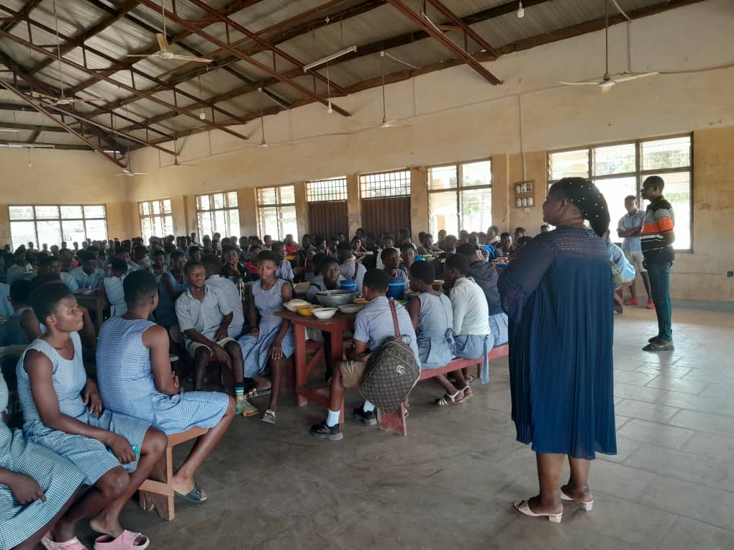THE EXECUTIVE DIRECTOR SPEAKING TO STUDENTS OF FUMBISI SENIOR HIGH/AGRIC SCHOOL ON P2Y ACTIVITIES ON TEENAGE PREGNANCY AND NEGATIVE IMPLICATIONS OF EMERGENCY CONTRACEPTIVES

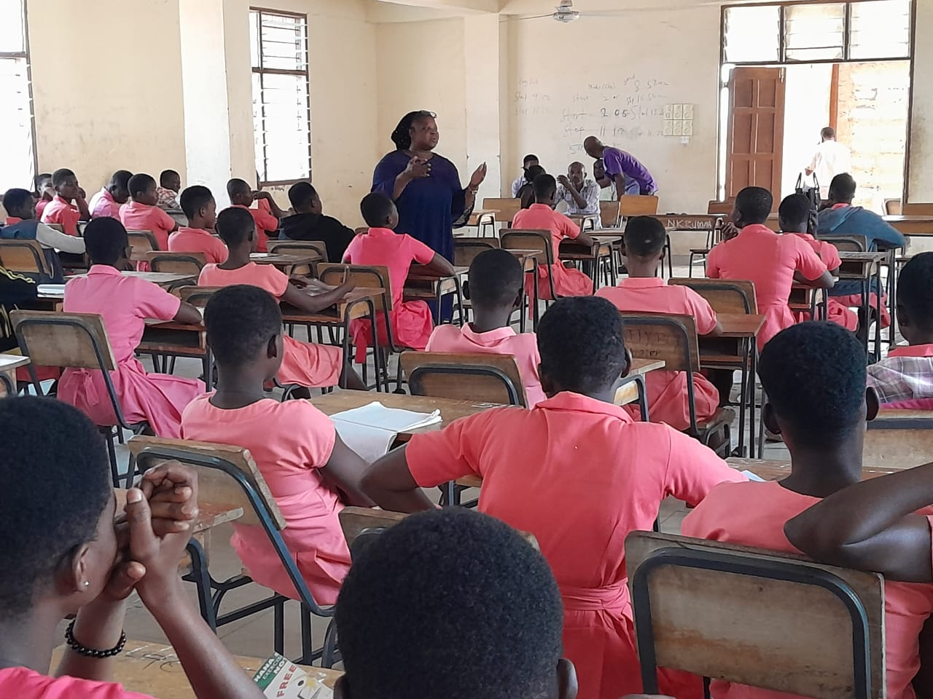THE EXECUTIVE DIRECTOR SPEAKING TO KANJARGA SENIOR HIGH SCHOOL CLUB ON P2Y ACTIVITIES ON PREVENTION OF TEENAGE PREGNANCY AND NEGATIVE IMPLICATIONS OF EMERGENCY CONTRACEPTIVES

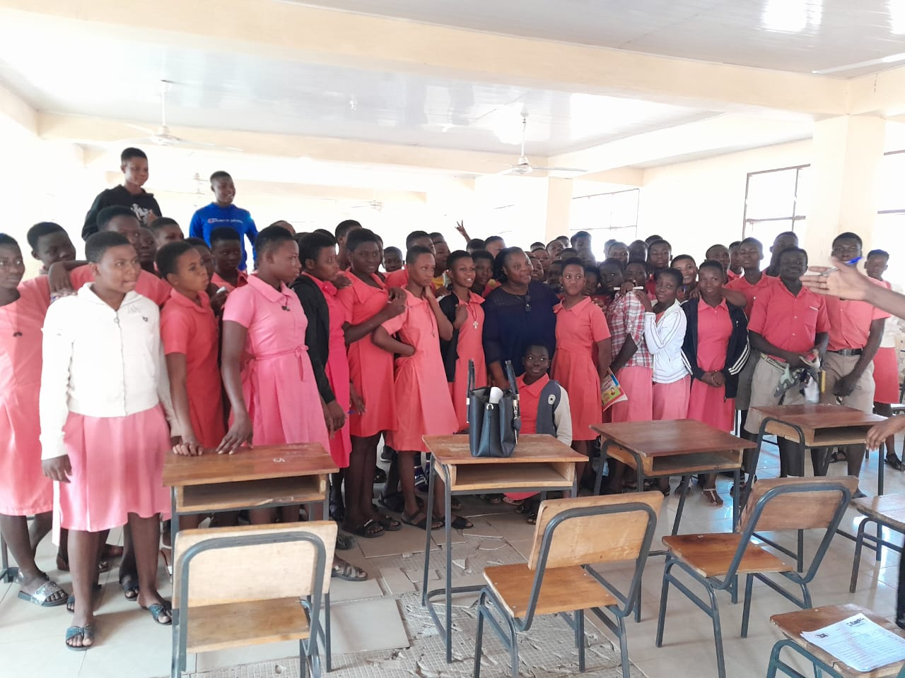GROUP PICTURE WITH KANJARGA SENIOR HIGH SCHOOL CLUB WITH FOCEP EXECUTIVE DIRECTOR

CONCLUSIONS

FOCEP had very positive interactive sessions with the various school clubs and the cooperation from both students and teachers was very interesting and educative. However, FOCEP wish to appeal to norsaac to consider the idea to continue to provide funding support to strengthen these clubs to enable them to become vibrant advocacy movements under the Power-to- Youth program.

Humbly submitted by:

Philomena Akayeng

(Executive Director)